Practical - 9

Practical Title: Secure User Registration with Database Insert, Duplicate Email Check, and Password Hashing

Problem Definition:
Implement secure user registration by inserting user details into MySQL
using MYSQLi. Validate input on frontend and backend, check duplicate
email/username, hash passwords using password_hash(), and display
appropriate messages.

Theory:
1. Is password_hash() used before storing passwords?
Yes, PHP's password_hash() function is used to hash the password before storing it in the database. This helps protect user passwords and prevents storing them as plain text.
2. Is duplicate email/username checked?
Yes, the database is checked for an existing email address or username before inserting a new user. If a duplicate is found, an appropriate error message is displayed, and the registration is not completed.
3. Are frontend and backend validations consistent?
Yes, frontend and backend validations are kept consistent. Frontend validation provides immediate feedback to users, while backend validation checks the submitted data again to ensure security and correctness.

- Implementation/ Output/Result
https://github.com/margiruparel2907-collab/webdev/tree/master/Prac_9
- Evidence of Work (Screenshots)
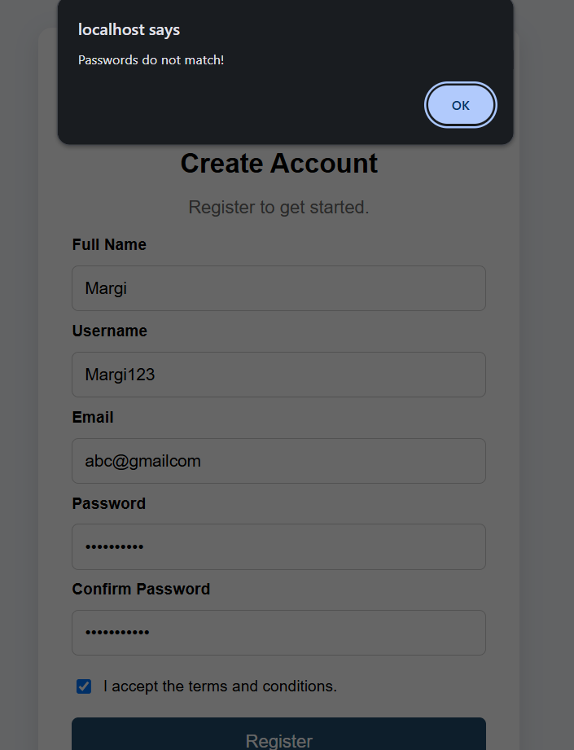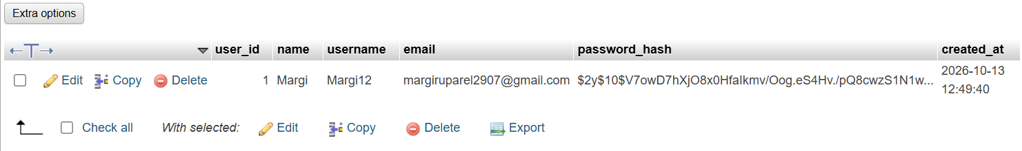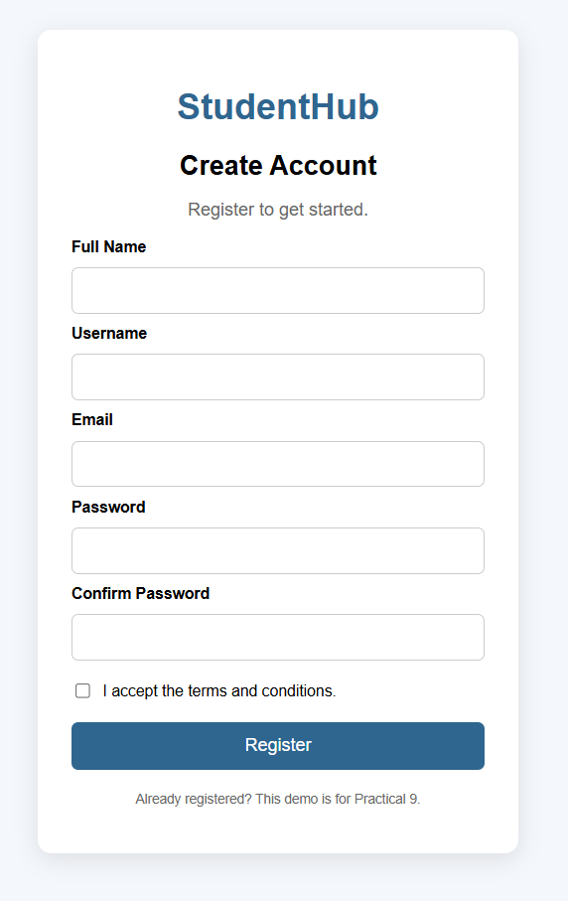
- GitHub Repository Link:
https://github.com/margiruparel2907-collab/webdev

- Challenges Faced:
During this practical, I faced challenges in validating user registration details, checking for duplicate email addresses and usernames, and inserting records into the MySQL database. I also learned how to hash passwords securely and handle invalid inputs and database errors.

- Learning Outcomes:
Through this practical, I learned how to implement secure user registration using PHP and MySQLi. I understood the importance of frontend and backend validation, duplicate email and username checks, and password hashing using password_hash(). I also learned how prepared statements help prevent SQL injection and improve the security of registration systems.

Faculty Remarks: (Keep this blank for faculty)

